# Introduction

In this 4th-year project, the team has chosen to utilize the Scrum framework, a widely recognized Agile project management methodology, with Santos serving as the Scrum Master. Scrum emphasizes collaboration, flexibility, and continuous improvement, making it an ideal choice for the team as they tackled complex and evolving requirements.

To effectively implement the Scrum framework, the team has used Scrumwise, a powerful and user-friendly project management tool. Scrumwise has played a crucial role in the project's success by providing a comprehensive platform for managing tasks, tracking progress, and facilitating communication among team members.

As the Scrum Master, Santos has been responsible for ensuring that the team follows Scrum principles and practices, as well as facilitating communication and collaboration between team members using Scrumwise. Santos' primary goal has been to create an environment in which the team could work efficiently, adapt to change, and deliver high-quality results throughout the project.

In this section, the experiences and insights of Santos as the Scrum Master will be shared, focusing on how the team effectively utilized the Scrum framework and Scrumwise to drive the project towards successful completion.

Top of Form

Bottom of Form

# Sprint Planning

During the course of the project, the team adopted a sprint planning approach that typically involved one to two-week sprints. At the end of each sprint, the team gathered to plan the upcoming sprint, ensuring a smooth transition and continuous progress.

The sprint planning sessions began with outlining the end goal for the upcoming sprint. This step was essential in providing a clear direction and helping team members understand the objectives they needed to achieve. By setting a well-defined goal for each sprint, the team was able to maintain focus and work collaboratively towards a common target.

Next, the team discussed each backlog item in detail. This process allowed all team members to gain a thorough understanding of the tasks and their importance to the project. It also enabled the team to identify any dependencies or potential roadblocks that could impact the sprint's progress.

During these discussions, the team worked together to assign points to each backlog item, representing the level of effort and complexity involved in completing the task. By reaching a consensus on the points assigned, the team ensured that everyone had a shared understanding of the workload and could distribute tasks fairly among the members.

The sprint planning sessions were instrumental in fostering a collaborative and transparent environment within the team. By openly discussing goals, tasks, and expectations, the team was able to align their efforts and work more efficiently throughout each sprint.

# Sprint Release

For the final release of our project, we devised a strategic plan outlining the essential features we aimed to complete before the expo. Our primary objective was to ensure that users could seamlessly book cooks and make payments through our platform. To achieve this goal, we divided the work into three distinct sprints, each focusing on specific aspects of the desired functionality.

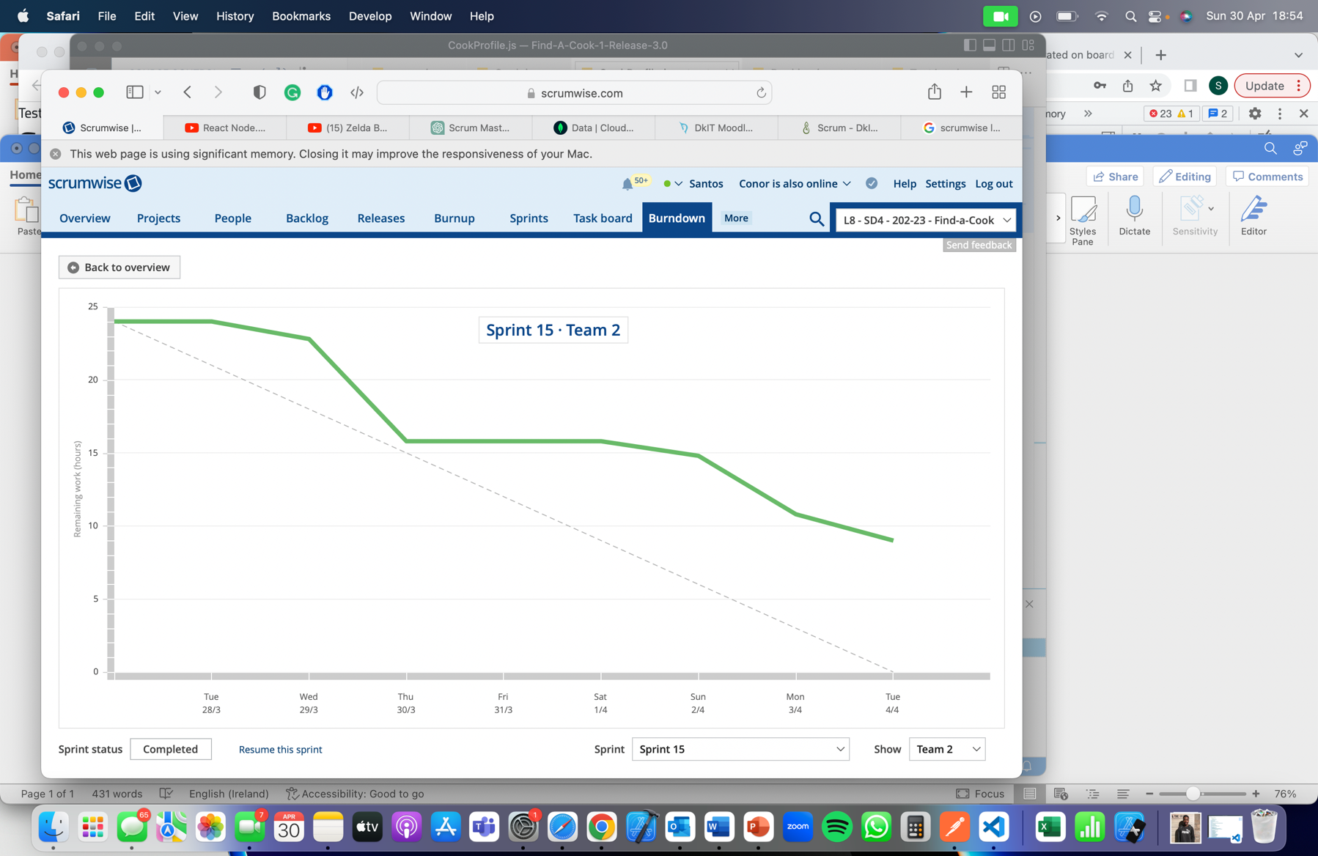

For the first sprint we were not able to complete all of our tasks.

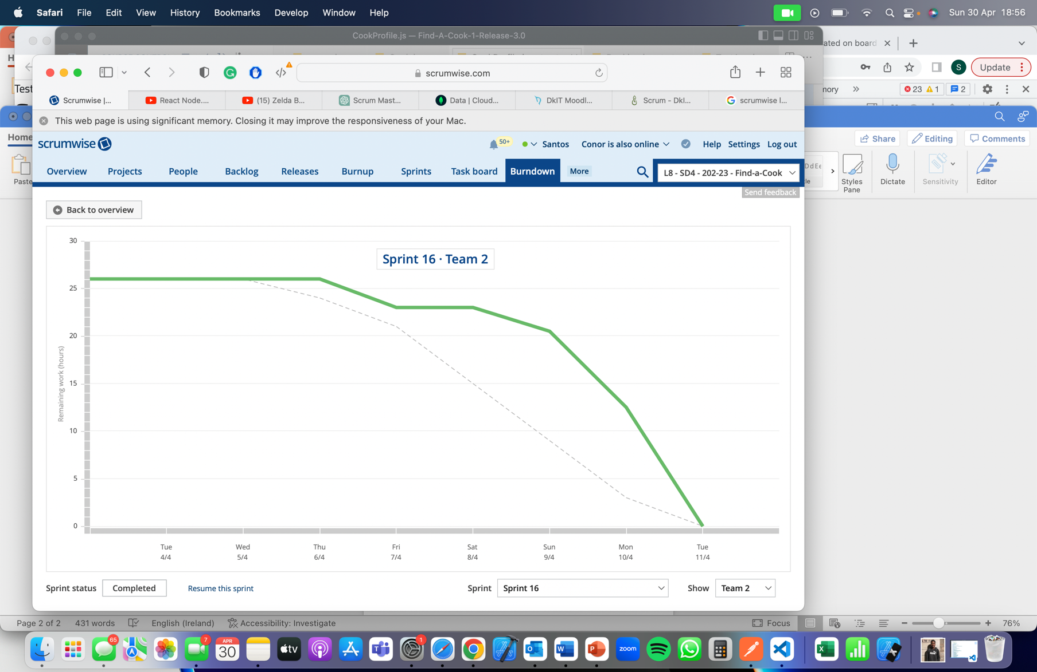

In the second sprint due to piling Cas we got a very late start we reduced the workload for this sprint and were able to complete all of the tasks remaining in a short time.

For the final sprint we were not able to complete the tasks in time for the sprint.

## Release 3 Goals

* Refine Cooks profile
* Fix a few major bugs
* Implement booking system
* Deploy app

## Release 3 Issues

* Not enough time dedicated to Release
* External factors impacted time able to be dedicated to Release
* Booking system difficulties